
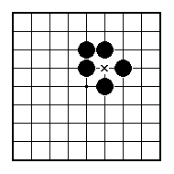
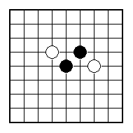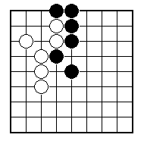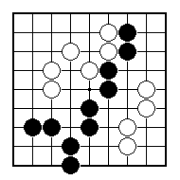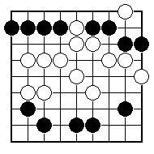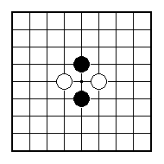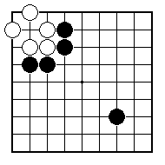
Can White cut the two black stones apart?

Can White cut the two single black stones apart?

Can White cut the black group in two?

How can Black connect up his stones at the top to form one group?

What is Black’s best play?

Where can White cut?

NAME:
BRITISH GO ASSOCIATION CERTIFICATE LEVEL 2 - SHEET 1

CUTTING AND CONNECTING

